# Progress review:

## Background

### State of the art

One of the hottest topics in condensed matter physics is the realization of a quantum computer. The main advantage of such a quantum computer would be its ability to solve specific classes of algorithms orders of magnitudes faster than classical computers. A classical computer is based on deterministic two level states called bits. A quantum computer is also based on two level states (basis states) called quantum bits (qubits). However, a qubit unlike a classical bit exploits the quantum effect of superposition. As a consequence, a quantum system can be simultaneously in both basis states.

There have been several proposals for implementing such a qubit, with just some solid state realizations listed below:

* Electrons on Helium (He) [1]
* Semiconductors:
  + - Nuclear spin qubits [2]
    - Electron (hole) spin qubits [3]
* Superconductors:
  + - Flux qubits [4]
    - Charge qubits [5]

One of the above mentioned suggestions, which came in 1998 by Loss and DiVincenzo, was to use the spin of electrons (holes) for the realization of a qubit. The spin, an intrinsic quantum mechanical property of every elementary particle, lifts the degeneracy of an orbital energy level in the presence of an external magnetic field. The orbital level splits into two, typically labelled as spin-up and spin-down. This two level system can then act as a qubit, the so-called spin qubit.

However, for creating and manipulating the spin qubit, one must first confine the charge particle into a region, which is in size comparable to the charge particle wavelength. Such a confinement can take place in a structure called quantum dot (QD). QDs are very small structures (their diameters can reach tens of nanometers) and because of their almost zero dimensionality, the energy levels for a charge particle are discrete and far away from each other.

Not every two level system can create a useful qubit for the realization of a scalable quantum computer. In 1998 DiVincenzo published a list of conditions which a qubit should fulfill for a quantum computer to work correctly [6]:

The 5 necessary criteria are:

* **The qubit should be well-defined:** A well defined qubit is a two level (two state) system whose levels are distinguishable and highly controllable.
* **It should allow reliable state preparation:** The qubits need to be deterministically driven into the initial state so that the next computational step can take place**.**
* **It should show low decoherence times (long coherence times):** Because of the several noise sources to which a qubit is exposed its initially prepared state is lost (it does decohere) with time. It is desirable to have coherence times as long as possible.
* **A “universal” set of quantum gates which perform the state manipulations, should exist:** In the classical logic the Boolean function set (set of gates) is functionally complete or universal if any other function (gate) can be represented by it. The same functional universality applies for the quantum logic.
* **A qubit measurement capability (state readout) should exist:** After several state manipulations have been applied to the qubit, one should be able to read the computed result, it’s quantum state.

**For all types of qubits there is a battle between the manipulation time on one side and the coherence time on the other side. This is so because for performing quantum computation, many single operations need to be done before the system will decohere. The benchmark for the manipulation time is the minimum time needed for going from one state to the other.**

**For the spin qubits, which this proposal deals with, different materials have been investigated aiming to find the material with the highest coherence vs manipulation time ratio.**

**Materials**

Silicon **(Si)** has emerged as a promising material for the realization of spin qubits because it can be isotopically purified and left just with the 28Si isotope which is a zero nuclear spin element. Thus the nuclear noise can be eliminated and the coherence time boosted in comparison to the broadly used gallium arsenide (GaAs) [7]. The additional big advantage of Si is its compatibility with current CMOS technology. This could become very important when moving towards the realization of a large number of qubits as required by quantum algorithms.

There are several approaches of defining QDs in silicon.

One way is by means of a phosphorous (P) dopant. In that case a P atom behaves as an electron QD because of its confining potential. Andrea Morello’s Group at UNSW in Australia, by applying the spin echo pulse sequence, has measured electron spin coherence time T2ECHO exceeding 200 microseconds, in a non – isotopically purified Si:P system, while the duration of one full spin rotation (τπ) in this case was τπ = 150 ns [3]. By using isotopically purified 28Si:P samples and the nuclear spin of a P atom as a qubit, the same group has achieved nuclear spin coherence time of T2ECHO = 60 milliseconds and τπ ≈ 25 μs [2].

M. Veldhorst et al. by using lithographically defined electron QDs in Si have measured spin coherence times using the CPMG pulsing technique of T2CPMG = 28 ms and τπ = 1.5 μs [8]. Finally, E. Kawakami et al. by using a single-electron QD in a Si/SiGe heterostructure qubit, have measured T2ECHO = 40 μs, while τπ = 0.15 μs [9].

One limitation of Si is the difficulty to perform fast gate operations while maintaining the good coherence. One way around this problem is to use the spin-orbit interaction of holes instead of electrons and perform spin manipulation via electric fields (as described in more detail in the *Spin dynamics experiments* section). Using this approach R. Maurand et al., realized very recently the first CMOS spin qubit by using a hole confined in a transistor made out of p-type Si. Indeed, the time for a full spin rotation was much reduced τπ ≈ 6 ns but also the reported T2ECHO ≈245 ns. [10].

**Holes in** **germanium** **(Ge)**, have an even higher spin orbit coupling which should allow thus much **faster spin manipulation times**. In addition, for purely heavy-hole (HH) states the **dephasing time should be very long** [11].

In our group we study qubits in Ge self-assembled nanostructures [12], which are created by epitaxial growth of Ge on Si. Such a growth can lead to various types of nanostructures. In this project the so-called Ge hut-wires are going to be studied. Very recently magnetotransport measurements have shown that holes, in this type of structures, are of HH character [12], suggesting long coherence times for this material system.

**C:\Users\jkukucka\Documents\GitHub\Fellowship\Diamond_Hannes.tif**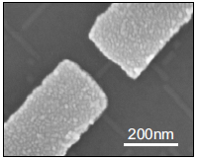

Figure 1: Stability diagram of a SiGe hut-wire single QD (left). Scanning electron micrograph of a Ge hut-wire contacted by palladium Pd source and drain electrodes (right) [12]

### Measurement techniques

Different type of measurement techniques have been used in order to extract the state of a spin qubit and its coherence time:

* DC current readout: The DC current readout is sensing the electron transport through the qubit by means of current measurement. It is prone to low frequency 1/f noise and the bandwidth (BW) is low because of heavy filtering necessary for achieving low effective electron temperatures.
* Differential measurement (AC current readout): The differential measurement (AC current readout) has a similar drawbacks as the DC current readout. It is typically done with a low frequency lock-in technique. Because of the low frequency noise, a lock-in amplifier usually operates on a very narrow bandwidth (BW) around the measurement frequency, which leads to long measurement times.
* Ohmic reflectometry: Ohmic reflectometry is a technique which indirectly senses the impedance change of a QD by monitoring the amplitude or phase of the reflected wave from the QD (see Figure 2 for a more detailed explanation). It is usually performed by high frequency lock-in techniques and is not prone to 1/f noise.
* Gate reflectometry: Similar to the ohmic reflectometry but it is connected to a gate electrode and not to a source or a drain. **It’s big advantage is that it does neither require charge transport through the QD hosting the qubit nor the existence of a charge sensor typically used with ohmic reflectometry.**

## What is done so far

During the first year of my PhD I have already prepared a 4K dip stick (Figure 2) for reflectometry measurements. Particular attention was paid to the sample holder, fabricated out of a printed circuit board (PCB).

DC electrical signals are sent to the sample through low thermal conductive wires twisted in pairs finishing in a PCB connector; radio frequency (RF) signals are sent through the coaxial cables. The DC signals are low pass filtered with surface mounted RC filters (Figure 3) to reduce thermal noise from the wires. After low pass filtering, the DC signals are routed to the gold plated bonding pads around the area in the middle of the PCB (sample area) on which a typically 5x5 mm2 sample is glued with the silver paste (Figure 3). The RF coaxial lines are finishing on the PCB mounted SMP connectors (Figure 3). After the SMP connector, a DC signal is added to the RF signal using a bias tee. From there the signal is routed to the PCB bonding pads. Electrical contacts from the PCB bonding pads to the sample bonding pads are achieved by wedge wire bonding.

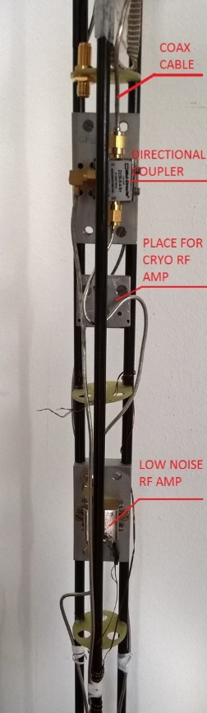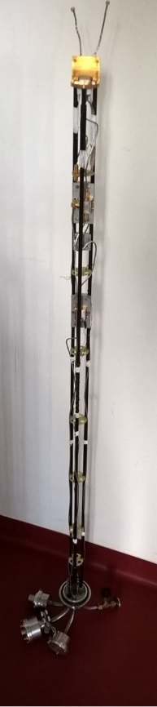Figure 2: The plexiglas 4K dip-stick used for cooling down the samples to 4K and performing the reflectometry measurements. The left picture shows the whole stick, while the right is a zoom-in, highlighting the directional coupler and the low noise Minicircuits ZX60-33LN-S+ RF amplifier. An additional low noise cryogenic RF amplifier CITLF2 from Sander Weinreb’s Caltech Microwave Research Group can be added in order to increase the SNR of the measured signal.

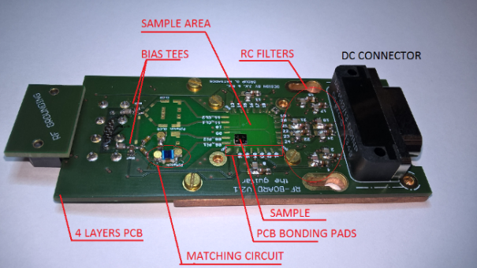Figure 3: Initial version of the PCB sample holder for the ohmic reflectometry. The upper figure shows the upper view of the PCB while the lower figure focuses on the back side.

**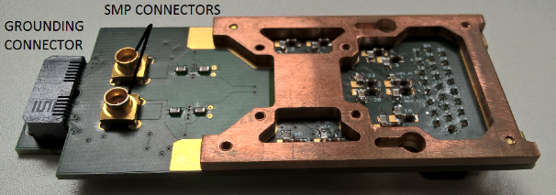**

The resonant circuit consists of a matching circuit (Figure 3) and the single hole transistor (SHT). For the matching circuit, the surface mounted inductor Murata 1.2 μH and the varactor MACOM MA46H070-1056 were used. The Varactor – a voltage tunable capacitor - was used in order to

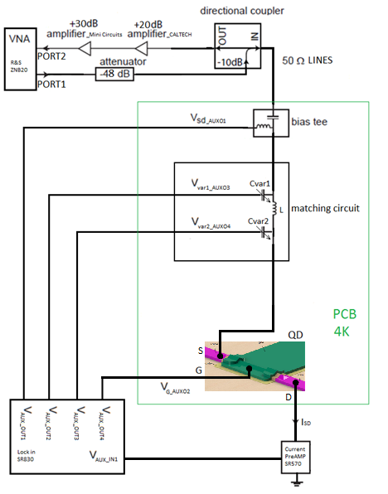Figure 4: Simplified schematic of the overall ohmic reflectometry measurement circuit

be able to always achieve a good matching condition.

For performing the ohmic reflectometry measurements the RF signal was sent down the coax line (Figure 2, right) towards the QD device. The signal which gets reflected from the resonant circuit is sent via the directional coupler to the amplifiers. The amplifiers configuration, shown in Figure 2 (right), is used to preserve the signal to noise ratio (SNR). After the sample, the very low noise cryogenic amplifier, Weinreb’s CITLF2, is used to amplify both signal and noise by the same amount (around 20 dB), adding a very small amount of itself noise, thus almost equalizing the SNR on its input with the SNR on its output. Thus higher noise level on the output of the CITLF2 amplifier allows the second, noisier amplifier to achieve the SNR on its output approximately the same as the SNR on its input. Such an amplifier chain enables non – degrading propagation of the SNR from the sample stage to the higher noise, room temperature electronics.

For conducting the measurements several instruments have been used.

* Reflection coefficient measurement: vector network analyzer (VNA) from Rohde and Schwarz, model ZNB20
* DC biasing of the single hole transistor: auxiliary bias outputs of a Stanford Research SR830 lock-in amplifier
* DC current measurements: current amplifier from Stanford Research SR570
* For attenuating the RF signal sent to the sample: Minicircuit’s attenuator
* For amplifying the reflected from the sample RF signal: series of CITLF2 and Minicircuit’s low noise amplifier
* Instrument control and data retrieval to the PC: Python application.

### Low temperature electronic transport measurements with the initial version reflectometry setup

The SHT sample was fabricated by H. Watzinger and the nanofabrication description can be found in [12]. Using the setup described in the previous chapter, the SHT (single QD) formed in the germanium hut-wire (Figure 5, left) was tuned in the Coulomb blockade regime applying DC voltages on source, drain and gate electrodes (Figure 4). Charge stability measurements were conducted in the Coulomb blockade regime showing a Coulomb diamond pattern. A comparison of the DC current and the ohmic reflectometry measurements has been done. The DC current was measured by applying a bias on the source and reading the current from the drain contact (Figure 4), while for the reflectometry measurement the LC matching circuit was connected to the SHT source contact (Figure 4).

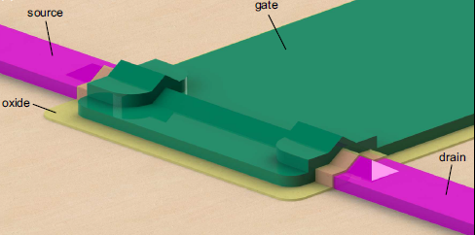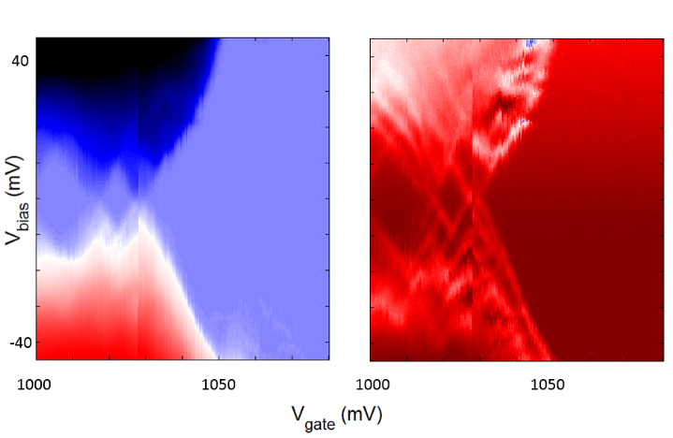

Figure 5: (Left) 3D model of a SiGe nanowire-based single QD sample - SHT, designed by H. Watzinger. A single QD which confines holes is formed in the nanowire beneath the gate (green). Comparison of the DC current transport (middle) and the ohmic reflectometry (right) measurements on the SHT in a Ge hut-wire.

By adjusting the integration time to be similar for both measurements, it can be seen that the reflectometry technique enables us to see more features like the excited orbital energy states of the SHT (Figure 5, middle and right).

We have compared our reflectometry setup with the one of D. J. Reilly et al. for which they reported conductance sensitivity of 5\*10-6 e2/h Hz−1/2 by performing reflectometry on a quantum point contact in a dilution fridge with electron temperature of 120 mK [13].

We have measured a just around five times lower sensitivity despite the much higher temperature of 4K. This is quite good when considering that the thermal broadening of the energy levels at 4K leads to a much wider coulomb peaks. Such results in a much smaller resistance change for a small gate voltage modulation and thus a smaller sensitivity.

***THIS PART IS CHANGED FROM GOING TO BE DONE (AS IN PROPOSAL) TO ALREADY DONE FOR THE PROGRESS REVIEW***

### Second version reflectometry setup

The first generation of the used setup and the PCB board aimed to verify that indeed we have the knowhow to perform RF reflectometry measurements. The second generation of the reflectometry setup is installed in a dilution fridge reaching temperatures down to 10 mK.

For the purpose of measuring several samples and due to the necessity for a higher number of RF lines dictated by the experiments of spin manipulation, a new PCB is designed. The new design allows frequency multiplexing of four different reflectometry resonant circuits enabling the measurement of four devices by using just one RF line and amplification stage. We installed in the dilution fridge insert a similar reflectometry system like the one used in the 4K dip-stick. However there are several improvements. There is an upgrade in terms of using lower thermal conducting stainless steel cables, attenuators, and additional DC filtering of all the DC wires. In addition, a Niobium titanium superconducting cable is used between the input of the cryogenic amplifier and the sample stage because of its very low thermal conduction, to avoid heating of the mixing chamber stage of the fridge which has a cooling power of a few tens of μW in the insert.

The vector network analyzer which was used so far for the measurements is replaced with a Zurich Instruments UHF lock in amplifier which enables faster and longer data acquisition, more inputs and generally more measurement flexibility. For the spin relaxation time and the spin manipulation measurements, arbitrary waveform microsecond pulses with a nanosecond rise time are needed. Those are generated using a Tektronix arbitrary waveform generator (AWG) 5014C. The measurements are conducted using the QTLab measurement application developed in Python initially by the Delft Quantum Transport (QT) laboratory. We modified it according to our needs. All the codes can be found on the GitHub: <https://github.com/nanoelectronics-new/qtlab>

## Working plan for the future

### Gate reflectometry design and spin dynamics experiments:

Gate reflectometry is going to be designed as a readout system for studying a hole spin qubit, realized in a germanium hut wire-based, double quantum dot. The gate reflectometry will use already defined gates needed for the electrostatic definition of the double quantum dot (DQD) system.

To examine the quality of our structure as a potential qubit, several experiments will be performed, after the gate reflectometry is set up. Those are measurements for determining the spin relaxation time T1, the spin dephasing time T2\*, the spin echo T2ECHO  time and the CPMG T2CPMG time. All measurement are going to be performed in a dilution fridge with DC and RF lines, amplifiers, attenuators and directional couplers. DC electronics, microwave sources, arbitrary waveform generators, lock-in amplifiers for gate reflectometry readout and superconducting magnets will be used to perform the experiments and realize the goals of the suggested project.

# References:

1. Platzman, P. M.; Dykman, M. I.; *Science* **1999,** *284,* 1967-1969
2. Jarryd J. Pla et al. *Nature* **2013** 496, 334–338
3. Jarryd J. Pla et al. *Nature* **2012** 489, 541–545
4. Morello et al. *Nature* **2010** 467, 687
5. Xiaobo Zhu1 et al. *Nature* **2011** 478, 221–224
6. David P. DiVincenzo [*arXiv:quant-ph/0002077v3*](http://arxiv.org/abs/quant-ph/0002077v3)
7. Zwanenburg, F. A. *Rev. Mod. Phys.* **2013**, 85, 961.
8. [M. Veldhorst](http://www.nature.com/nature/journal/v526/n7573/abs/nature15263.html#auth-1). *Nature* **2015**52,410–414
9. [E. Kawakami](http://www.nature.com/nnano/journal/v9/n9/abs/nnano.2014.153.html#auth-1) et al. *Nat. Nanotechnology* **2014** 9, 666–670
10. R. Maurand et al. [*arXiv:1605.07599*](https://arxiv.org/abs/1605.07599)
11. Jan Fischer and Daniel Loss *Phys. Rev. Lett.* **2010** 105, 266603
12. H. Watzinger et al.  [*arXiv:1607.02977*](https://arxiv.org/abs/1607.02977)
13. [D. J. Reilly](http://scitation.aip.org/content/contributor/AU0359152;jsessionid=0v5VY-bGXJiQk8fx_SoWO4Dw.x-aip-live-02) et al. *Appl. Phys. Lett.* **2007** 91, 162101